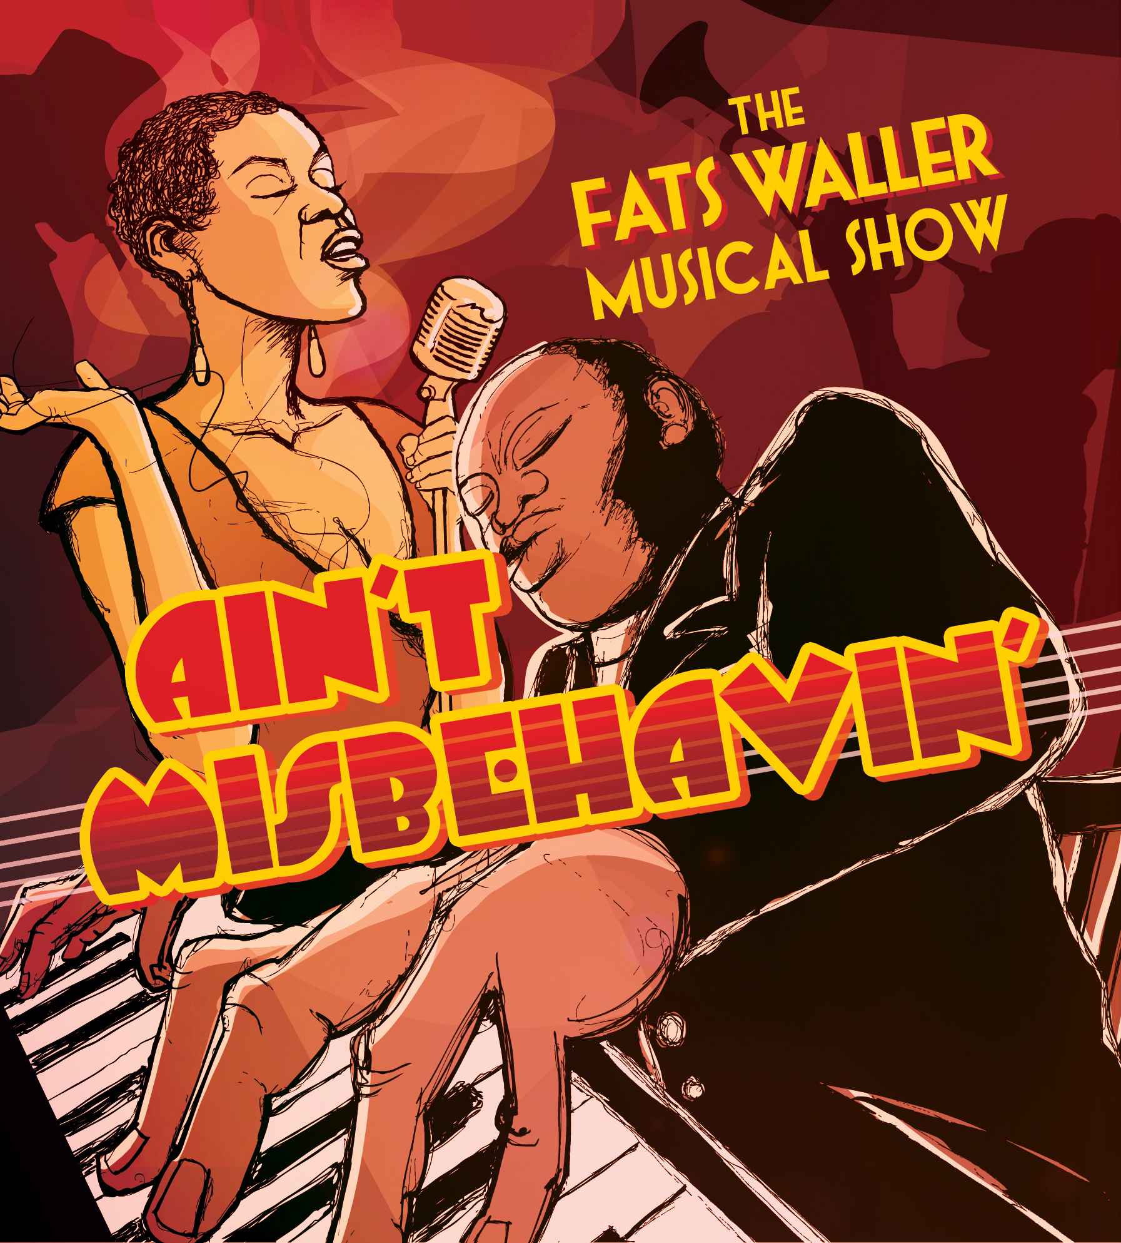
PRESS CONTACT: Nancy Richards – 917-873-6389 (cell)/nancy@northcoastrep.org
MEDIA PAGE: www.northcoastrep.org/press

FOR IMMEDIATE RELEASE, PLEASE:
NORTH COAST REP PRESENTS
AIN’T MISBEHAVIN’
THE FATS WALLER MUSICAL SHOW
Conceived by Richard Maltby, Jr. & Murray Horwitz
Created and Originally Directed by Richard Maltby, Jr.
Performances Beginning Wednesday, July 13, 2016
Running Through Sunday, August 7, 2016
Directed by Yvette Freeman

Solana Beach, Calif. AIN’T MISBEHAVIN’ is a roof-raising musical tribute to the black musicians of the ‘20s and ‘30s. Based on the signature Fats Waller song, this rousing musical revue takes audiences back to the glory days of the Harlem Renaissance when the Cotton Club and Savoy Ballroom served as playgrounds for high society. You’ll be tapping your feet as five performers take you on a journey, presenting an evening of rowdy, raunchy, and humorous songs. Directed by Yvette Freeman, known for her work as a television actress in the medical drama series “ER”, who replaced Nell Carter in the original Broadway production of AIN’T MISBEHAVIN’. Later, Ms. Freeman went on to direct the show all over the country.
Yvette Freeman directs Yvonne, Cynthia Thomas*, Ron Christopher Jones*, Anise Ritchie* & Tony Perry*. Marty Burnett (Scenic Design), Matthew Novotny (Lighting), Melanie Chen (Sound), Andrea Gutierrez (Props) and Peter Herman (Wig & Hair). Cindy Rumley* is the Stage Manager.
*The actor or stage manager appears through the courtesy of Actors’ Equity Association, the union of professional actors and stage managers in the United States. For background information and photos, go to www.northcoastrep.org/press.

Busy director Yvette Freeman and her talented cast are available for interviews by phone, in person, and in- studio. For more information and to arrange interviews or press tickets, please contact Nancy Richards at nancy@northcoastrep.org, or 917-873-6389 cell.

AIN’T MISBEHAVIN’ previews begin Wednesday, July 13. Opening Night on Saturday, July 16, at 8pm includes a post-show reception. There will be a special talkback on Friday, July 22, with the cast and artistic director. It will play Wednesdays at 7pm, Thursdays through Saturdays at 8pm, Saturday and Sunday matinees at 2pm with Sundays at 7pm, through August 7, 2016 (See Schedule below.) North Coast Repertory Theatre is located at 987 Lomas Santa Fe Drive, Solana Beach, CA 92075. Tickets: Previews- $42; Week Nights - $49; Sat. Eve. & Sun. Mat.- $53; Sat. Mat. & Sun. Night - $46. Seniors, Students, Military - $3 off admission. Call 858-481-1055 or visit www.northcoastrep.org to purchase tickets.

We have extended our run at the California Center for the Arts, Escondido from August 11- 14. For tickets, call (800) 988-4253 or Visit - artcenter.org (Link - http://artcenter.org/event/aint-misbehavin/2016-08-11/)

FACT SHEET

WHAT: NORTH COAST REPERTORY THEATRE presents
Ain’t Misbehavin’
The Fats Waller Musical Show
Conceived by Richard Maltby, Jr. & Murray Horwitz
Directed by Yvette Freeman

CAST: Yvonne, Cynthia Thomas, Ron Christopher Jones, Anise Ritchie & Tony Perry.

WHERE: North Coast Repertory Theatre
987 Lomas Santa Fe Drive, Ste. D
Solana Beach, CA 92075

SCHEDULE*: Previews: July 13 - 15, 2016
Opens: July 16, 2016, at 8 pm
Closes: Aug. 7, 2016
Wed. @ 7pm, Thurs-Sat @ 8PM; Sat & Sun @ 2PM, Sun @ 7pm
Talkback with cast & director: Friday, July 22, 2016

*Extension week from August 11-14 (6 performances)
at CENTER THEATRE at California Center for the Arts, Escondido. . Performance times: Thursday – Sunday at 7:30pm and Saturday and Sunday at 3pm. For tickets, call (800) 988-4253 or visit artcenter.org
(Link - http://artcenter.org/event/aint-misbehavin/2016-08-11/)

PRICES: Previews $42.00
Week Nights $49.00
Sat. Matinees & Sunday Nights $46.00
Sat. Nights & Sunday Matinees $53.00

DISCOUNTS: Seniors, Students, Military $3.00 off admission

BOX OFFICE (858) 481-1055 or www.northcoastrep.org

JULY
Schedule at North coast rep
SUN |  | MON | TUE | WED | THU | FRI | SAT
 |  |  |  | 13  Preview  8pm | 14  Preview  8pm | 15  Preview  8pm | 16  OPENING  8pm
 | 17  2pm & 7pm | 18 | 19 | 20  7pm | 21  8pm | 22  8pm  Talkback | 23  2pm & 8pm
 | 24  2pm & 7pm | 25 | 26 | 27  7pm | 28  8pm | 29  8pm | 30  2pm & 8pm
 | 31  2pm & 7pm | AUG. 1 | 2 | 3  7pm | 4  8pm | 5  8pm | 6  2pm & 8pm
7
2pm

You can catch the extension at CENTER THEATRE at California Center for the Arts, Escondido from August 11- 14.

BACKGROUND:
About the North Coast Repertory Theatre
North Coast Repertory Theatre is a professional Equity theatre founded in 1982, currently celebrating its 34th season, North Coast Rep has received critical acclaim from media and audiences alike, and has evolved into one of the area’s leading performing arts organizations. North Coast Rep prides itself on employing the majority of its actors from Actors’ Equity Association for its high quality, award-winning productions, and staging works by established and emerging playwrights. Throughout its history, North Coast Rep has created a platform where artist and audience thrive through the intimacy of live theatre, recognizing the power of theatre to challenge complacency, revitalize the imagination, nurture the unexpected and embrace the variety and diversity in our lives.

About the California Center for the Arts, Escondido
With a mission of bringing people together to discover, create and celebrate both the visual and performing arts, the California Center for the Arts, Escondido is the cultural center of North San Diego County. The Center's unique campus includes a 1,523-seat concert hall, a 404-seat theater, a contemporary art museum, art and dance studios, and a full-service conference center with meeting and banquet facilities. The Center also runs an extensive education program and produces free community events. San Diego Magazine named the Center the "Best Limited Engagement" in North County, and the Center was named in the Top Five for U-T San Diego’s Readers Poll for "Best Live Music Venue." The Center is located at 340 N. Escondido Blvd. in Escondido. The Ticket Office can be reached at (800) 988-4253. Tickets can also be purchased online. To learn more, including performance dates, times and ticket information, visit artcenter.org.

BIOS:
MURRAY HORWITZ (Conceived by): In 1973, after moving to New York City, Horwitz appeared in the one-man show, An Evening Of Sholom Aleichem, which was directed by Richard Maltby Jr, and in which he continues to perform at The Kennedy Center, The Manhattan Theatre Club, and The New York Shakespeare Festival/Public Theater. In 1978, Horwitz and Maltby created the Broadway musical Ain’t Misbehavin', which won Tony, Obie, Emmy, Grammy, and New York Drama Critics' Circle awards. Since 1998, Horwitz has been creative consultant to the annual Mark Twain Prize ceremonies at the Kennedy Center. In 1989, he began his career at NPR, where he created several series, including Wait, Wait…Don’t Tell Me, Wynton Marsalis: Making the Music, and The NPR Basic Jazz Record Library. Horwitz received three Peabody awards for his work at NPR. In 2002, Horwitz became the founding director of the AFI Silver Theatre and Cultural Center. Horwitz was the director and chief executive officer of the AFI Silver Theatre and Culture Center from 2002 until 2009.

RICHARD MALTBY JR. (Conceived by) a graduate of Yale University who is also a director, wrote lyrics for Starting Here, Starting Now (1977, directed also), Ain't Misbehavin' (1978, provided additional lyrics, conceived and directed - Drama Critics Circle Award, Drama Desk Award, Obie Award for Best Musical, Tony Awards for Best Direction of a Musical and Best Musical), Baby (1983, directed also - nominated for seven Tony Awards), Song and Dance (1985, co-lyricist and director), Miss Saigon (1989, co-lyricist - London Evening Standard Award for Best Musical), Closer Than Ever (1989, directed also - Outer Critics Circle Awards for Best Score and Best Musical), Nick & Nora (1991) and big (1996 - nominated for five Tony Awards, including Best Score). He has also contributed crossword puzzles to Harper’s magazine.

ARTHUR FARIA (Original Broadway Choreographer) Mr. Faria created the original staging and choreography for the 1978 Tony Award-winning musical Ain’t Misbehavin’. He received both the Tony and Drama Desk award nominations, and shared the Obie for the original production at the Manhattan Theatre Club. Arthur recreated his work for the tenth anniversary Broadway revival starring the original cast. Lena Horne personally asked Arthur to direct and choreograph. He created, directed and choreographed Lena Horne in her triumphant return to Broadway in Lena Horne: The Lady and Her Music. Television credits include Emmy Award nominated NBC’s presentation of Ain’t Misbehavin’ and PBS’s “Great Performances” production of “Duke Ellington: The Music Lives On.” Mr. Faria holds a Doctorate Degree in Fine and Performing Arts from the University of Massachusetts at Dartmouth.

YVETTE FREEMAN (Director): Yvette Freeman is an actress, singer, painter, producer, and director. She is best known for playing the role of Nurse Haleh Adams on the award winning NBC drama “ER” for all 15 seasons, but she has now traded in her nurse’s scrubs for jailbird Irma’s uniform in “Orange is the New Black” – the Netflix series that has been lauded with numerous awards. The Wilmington, Delaware, native first starred on the stage in New York in the Broadway musical sensation Ain’t Misbehavin’, and from there she went on to star in stage productions with national and international companies. After tours throughout the United States, Europe, and Asia, she moved to Los Angeles and guest-starred on dozens of TV shows and motion pictures. In addition to her acting skills, Yvette also has a great singer voice. She won numerous awards for her performance in the play Dinah Was, based on the life of legendary jazz singer Dinah Washington. Yvette also won an Obie at the Gramercy Theatre, off-Broadway, as well as “Best Actress in a Musical” from the NAACP, Ovation Awards, and LA Weekly for the same play in 1996, in Los Angeles. In 1999, Yvette Freeman added director to her credits when she completed the American Film Institute’s program “Director’s Workshop for Women.” Her first film was “The Blessing Way”. She has gone on to write, direct, and produce several short films. Most notably, Yvette directed the film, “Remember”, a film about Alzheimer’s, which won several awards, including Best Short Story for the Moondance 2004 Film Festival. In 2011 Yvette directed Gee’s Bend at North Coast Repertory Company. She is a graduate of the University of Delaware, and holds a Master Degree in English and Creative Writing, with a concentration in screenwriting, from Southern New Hampshire University. In her personal life Yvette enjoys spending time with her husband, jazz pianist Lanny Hartley, oil painting, singing, and playing with her two dogs and two cats. She is currently seen in the national television commercial for Progressive Soup as the old white haired lady!

YVONNE (Charlaine) graduated from San Diego State University May 2015 with a Bachelor of Arts & a few minors. As a solo artist, Yvonne has appeared on television shows such as “Duets”, “Fox’s 3 Minutes to Stardom”, & “Chasing Destiny”. She has had the opportunity to sing for famous musicians such as John Legend, and more recently Kelly Rowland on BET. For the past 5 years, she has been in various musicals around San Diego & Los Angeles County, her favorite being Rizzo in Grease at the Welk Resort Theatre. Be sure to follow Yvonne on Instagram @officialyvonne. Enjoy the show!

CYNTHIA THOMAS* (Armelia): National Tour: Ain’t Misbehavin’ (starring the Pointer Sisters; dance captain/understudy). European Tour and Barcelona, Spain Ain’t Misbehavin’ Regional: Ain’t Misbehavin; Casper The Musical, starring Chita Rivera; Memphis; Show Boat; South Pacific; The Best Little Whorehouse in Texas; Once On This Island; Smokey Joe’s Café; The Music Man; Hairspray; A Christmas Carol; Film: “Malcolm X,” starring Denzel Washington. To name a few. Thanks to Arthur Faria, family, and friends for their love and support. Cynthia gives thanks and all the glory to God and is a proud member of Actors Equity. Follow her on Instagram.com/divahoney and on Twitter.com/Divahoney4u
RON CHRISTOPHER JONES* (Andre) is a native San Diegan and has performed professionally for over 20 years. Some of his favorite shows include Play On! at the Pasadena Playhouse, How the Grinch Stole Christmas at the Old Globe Theatre, and Bessies Blues at the San Diego Rep. Favorite roles include Mr. Magix in My One and Only, Scrooge in Christmas is coming Uptown, and the Mikado in the Hot Mikado. Ron thanks Karyn Overstreet Vocal Studios for helping him prepare for this role, and he is dedicating this performance to his beautiful wife Marylynn, and his fantastic 1 year old daughter Maisie. Ron recently won Best Supporting Actor at the 2016 San Diego Film Awards. Proud member of Actors’ Equity. RonChristopherJones.com
ANISE RITCHIE* (Nell) is thrilled to make her North Coast Rep debut. Most recently appeared in Violet, San Diego Rep., The Hunchback of Notre Dame La Jolla Playhouse and Papermill Playhouse, New Jersey; Leap of Faith, Ahmenson Theatre LA., Tommy San Diego Rep, Moonlight; Sammy, How the Grinch Stole Christmas, Old Globe; Nightmare Alley Geffen Playhouse LA; Suds Starlight; Once on this Island, Sparks Theaterworks; A Grand Night for Singing, Smoky Joe’s Café, Sophisticated Ladies California Rep; Little Shop of Horrors Portland Civic. She has toured the Northwest California tour of Ain’t Misbehavin’ and has toured Europe singing gospel. She has been heard on radio and television commercials. Proud member of Actors’ Equity. Twitter: @Aritchie1 and Instagram: aniser21

TONY PERRY* (Ken) New York: Allegro, 74 Georgia Ave., Shelter In Our Car, Martin: A New Beginning, Repo: The Genetic Opera, The Groove Factory, The Bonus Army. Regional: Memphis, Ain’t Nothing But the Blues, Parade, Cross That River, Ain’t Misbehavin, Five Guys Named Moe, Dreamgirls, The Wiz, Big River, Me and My Girl, Smokey Joes Café, The Rocky Horror Show, A Grand Night For Singing. Film: “Mickey,” “Finding Oz; A Journey Home.” He has traveled North America in a concert of Yiddish and African-American music, and has three CDs available at www.tonyperry.com and iTunes. Proud AEA member. Twitter: @TonyinNYC
JULIA LEMA (Choreographer) is very excited to be a part of the North Coast Repertory Theatre’s production of Ain’t Misbehavin’. A native New Yorker, Julia has performed on and off Broadway in such shows as Lena Horne, The Lady & Her Music, Ain’t Misbehavin’, Guys & Dolls, Dreamgirls, Play On, Leader Of The Pack, Beehive, Blues In The Night, Swinging On A Star, Thunder Knocking On The Door, Crowns and To Kill A Mocking Bird. As a director/choreographer, Julia was assistant to Arthur Faria in the Pointer Sister’s production of Ain’t Misbehavin’ and remounted the show starring Martha Reeves & The Vandellas. She also directed and choreographed a production of Five Guys Named Moe at Stage West in Springfield, Mass. Most recently, she remounted another production of Ain’t Misbehavin’ at the Delaware Repertory Theatre directed by Richard Maltby. She gives all praise, honor and glory to her Lord and Savior, Jesus Christ.
LANNY HARTLEY (Musical Director): Lanny grew-up in a church environment which fostered his love for gospel music and was mentor by the legendary David Baker when he studied Music Education at Indiana University. His career encompassed pianist, composer, director, teacher, and solo performer. He has performed with such greats as: Linda Hopkins, Ernie Andrews, The Fifth Dimension, Joe Tex, Hugh Masakela, David Clayton Thomas, Wes Montgomery, Freddie Hubbard, Dizzy Gillespi, Buddy Collette, Bennie Mopin, James Newton (Luckman Jazz Orchestra), Grant Gershon (LA Master Chorale) - to name a few. He is also a graduate and instructor in Lyle “Spud” Murphy’s system of Horizontal Composition, based on Equal Intervals. As musical director for the musical Dinah Was, Lanny received nominations from the NAACP, Ovation Awards, and the New York Obie Awards. Dinah Was was a pivotal show for Lanny - he met, collaborated and married his wife of nineteen years - Yvette Freeman.

MUSICIANS:
KEVIN TONEY (Pianist / Conductor) Grammy nominated pianist, composer, recording artist and author. Theatre credits: Recorded In Hollywood, Words By Ira Gershwin, James Brown-A Celebration In Dance, Memphis, Atlanta, Five Guys Named Moe, Ain’t Misbehavin, Its Only Make Believe, Sophisticated Ladies, Dreamgirls, Smokey Joe’s Café, Henry IV, Ain’t Nothing But The Blues, Amen Corner. Was leader of "The Blackbyrds", band’s hits including "Walking In Rhythm,“Rock Creek Park”. Kevin's released twelve acclaimed solo albums and has performed or conducted for Aretha Franklin, The Jacksons, Whitney Houston, Donald Byrd, George Benson, Carl Anderson, Shirley Caesar and more. Kevin’s awards include two Grammy nominations, three RIAA Gold Record awards, NAACP Image Award, National Endowment For the Arts Grant, and is member of the Phi Beta Sigma Fraternity.

DANNY KING (Drums and Percussion) Born in Brooklyn, N.Y., began performing at the early age of 9 years old. Following high school, went on to study music at Queens College while performing at local venues including off Broadway theaters. Danny later joined the Marine Corps and become a member of "The Commandant's Own" The U.S. Marine Drum and Bugle Corps based out of Washington D.C. and for more than 20 years toured with that great musical unit all across the United States and abroad. Upon retiring from the Marines and moving to San Diego the music continued by playing for most (if not all) of San Diego theatres to include; the San Diego Repertory theatre, The La Jolla Playhouse, the Lambs players theatre, the Old Town theatre, The Common ground theatre company, The Moonlight Amphitheater, the Lawrence Welk resort theatre, the Avo theatre in Vista, Ca. The Horton Grand theatre and returning for the 4th time, The North Coast Rep. This is just the short list of local playhouses Danny has had the pleasure of performing with...oops I'm running out of time to list them all. I'm looking forward to hearing the music play. One never knows...Does one?

GREG MCKINNEY (Bass) is a musician who is as comfortable in the studio as he is on stage. The list of whom he had worked with is a who's who in the entertainment industry. He has toured with likes of Grammy awards winner artist Jody Watley, shared the stage with locally jazz hero Daniel Jackson and has recorded with Gospel legends Cassietta George, The Clark Sisters and Andrea Crouch. At home on both electric and acoustic bass, Greg brings that "feel good" vibe to whatever genre he happens to be playing.

JULIAN DAVIS (Trumpet) is delighted to be making his debut with North Coast Repertory Theatre. His other accolades include In The Heights (San Diego REP), Hairspray (San Diego REP), as well as opening for Justin Bieber, The Who, O-Town and more. He recently contributed to “Bass Clef Bliss: Terrence’s Path”, a film about a young man’s journey with Autism. He is a Student at San Diego State University majoring in Music: Business and Entrepreneurship.

MALCOLM JONES (Reeds – Tenor Sax & Clarinet) A graduate of SDSU School of Music and Dance, Malcolm Jones earned his Bachelors of Music in Jazz performance, specializing in Jazz Saxophone in addition to woodwind doubling and is currently pursuing his Masters of Music in Jazz Studies at SDSU. Malcolm currently performs in many groups around San Diego and plays a variety of genres in addition to jazz. Malcolm is proud to be performing in his first production for North Coast Rep.

CINDY RUMLEY* (Stage Manager): Credits include: Way Downriver; William Faukner’s ‘Old Man’, Chapatti, Side By Side By Sondheim, Freud’s Last Session, Mandate Memories, Dames at Sea, Two By Pinter, and Visiting Mr. Green with North Coast Rep. Snapshots with The Pico Playhouse, Bye Bye Birdie with San Diego Musical Theater, and Conference of the Birds with The Moscow Art Theater. Cindy has worked as a production assistant at North Coast Rep for Heroes, My Name is Asher Lev, 5 Course Love, King O’ the Moon, and The Drawer Boy. Cindy holds an M.F.A in stage management from UC Irvine and is a member of Actor’s Equity Association. In her free time, Cindy enjoys being married to the amazing Mr. Aaron Rumley.

DESIGN TEAM:
MARTY BURNETT (Resident Scenic Designer) Marty is in his 23rd season as Resident Designer/Technical Director at North Coast Rep. He has designed the last 166 shows. Other venues include Laguna Playhouse, Portland Stage Company, Drury Lane (Chicago), Claridge Hotel (Atlantic City), Union Plaza, Sahara Hotel, Hacienda in Las Vegas, Coronado Playhouse, Scripps Ranch Theater, Harrah’s Lake Tahoe. Marty is a proud alumni of Creighton University in Omaha, Nebraska.
MATTHEW NOVOTNY (Light Design) is pleased to be designing another show for North Coast Rep, where he has designed close to 40 shows over the past seven years. Matthew is currently the Lighting Designer in Residence for San Diego Musical Theatre as well as North Coast Rep, and his work can be seen at a wide variety of Theatres across San Diego. Matthew holds a BA in Technical Theatre from San Diego State, and a Masters Degree in Lighting Design from Boston University. Matthew is married to his beautiful wife Amanda, with 3 gorgeous children: Ragan, Harper and Heston.
MELANIE CHEN (Sound Design) is thrilled to be working with North Coast Rep again! She is a freelance sound designer who has designed over 50 productions in San Diego, Los Angeles, and San Francisco. Past North Coast Rep credits include Hedda Gabler, Way Downriver, Now You See It, Side by Side by Sondheim, Betrayal, Unnecessary Farce, Freud’s Last Session, Romance/Romance, Faded Glory, Mandate Memories, and Becoming Cuba. Melanie holds an M.F.A. in Sound Design for Theatre & Dance from UC San Diego. For more info, visit her website at www.melaniesound.com

ANASTASIA PAULOVA (Costume Design) has worked as a set and costume designer for more than 15 years in the United States, Western Europe and Russia. Her recent credits include: Now You See It, A Streetcar Named Desire, Steal Heaven, In the time of the Butterflies, The Mountaintop, Midsummer Night’s Dream, Macbeth, The Diary of Anne Frank, The House of Bernarda Alba, Princess Turandot, Cyrano de Bergerac, and Three Sisters. She holds an MFA from St. Petersburg State Theatre Arts Academy. Anastasia is the very happy mom of 9-year-old Nikolas.

ANDREA GUTIERREZ (Prop Design) has been working at North Coast Rep since 2012, beginning as the Stage Manager and Prop Master for our theatre school. She worked as backstage crew for the 32nd and the beginning of the 33rd Season, before taking over as Supervising House Manager and Volunteer Coordinator. Her previous prop credits include Hedda Gabler, Way Downriver; William Faulkner’s ‘Old Man’, Now You See It, Sherlock Holmes and the Adventure of the Great Nome Gold Rush, Chapatti, and The Fox on the Fairway, as well as two Seasons as properties assistant at Starlight Theatre. She received her B.A. in Theatrical Design and Production from UCLA’s School of Theatre, Film & Television, and is currently pursuing her M.A. from Johns Hopkins University.

#####

